Tower Hopscotch

Manual

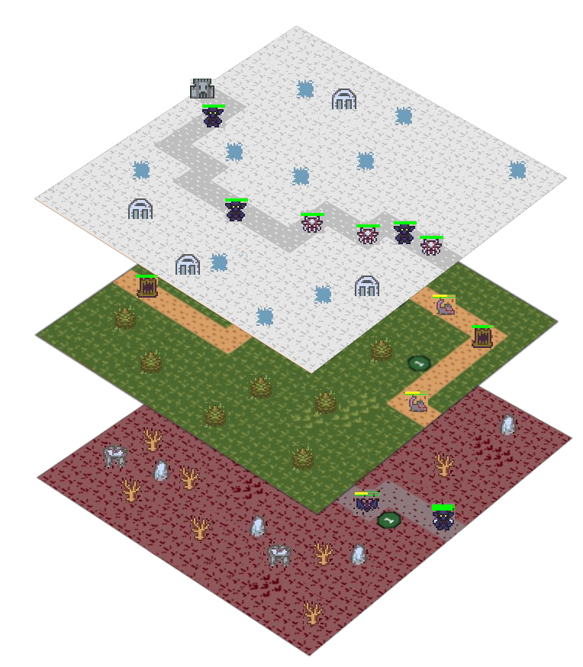

ZHAW School of Engineering, IT16a, Gruppe 5

Raphael Emberger Nicolas Eckhart Stefan Bösch Philipp Meier

08.12.2017

# Tower Hopscotch The Multi Layered Tower Defense Game

Tower Hopscotch is a new take on the popular video game genre called tower defense. The player’s ultimate goal is to survive multiple waves of enemies by building and managing towers. Said towers defend the castle and therefore the player’s health by shooting enemies. 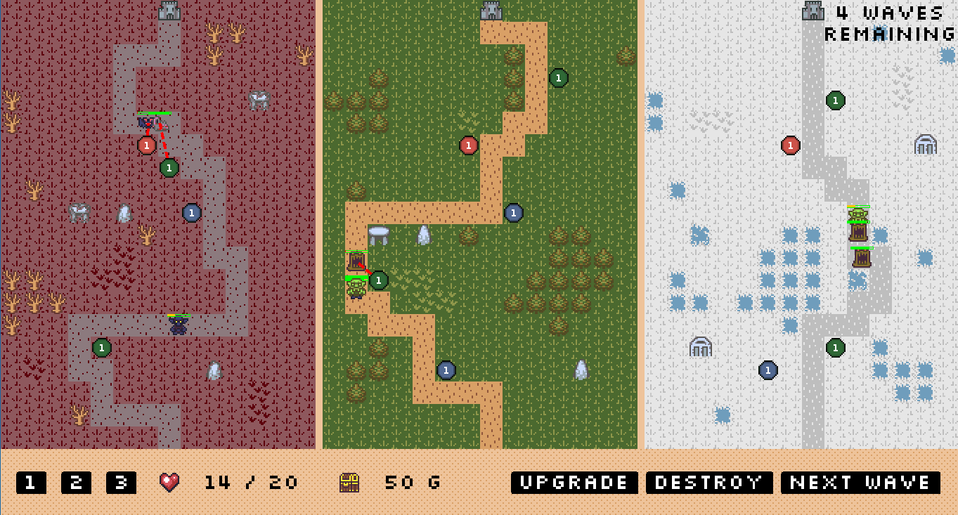

The challenge for the player is to build and upgrade towers in a strategic manner with a small amount of gold. Resource management and positioning of towers are the keys to success.

## Basic rules

* The player can build and upgrade towers by spending gold. It is also possible to salvage existing towers to get a fraction of the gold back.
* Enemy waves are called by the player manually until there are either no waves left, or the player has lost all his lives.
* Every enemy that walks into the castle reduces the player’s health.
* All Enemies move forward down the lane. But keep in mind, some of them can switch between the layers.
* Towers can shoot enemies in a defined range to reduce their health and eventually kill them. For every destroyed enemy, the player receives a small amount of gold.

### Prototype Disclaimer

Since this is only the prototype of the game, the different layers Hell (red), Earth (green) and Heaven (white) are only presented two dimensionally.

# Game Loop

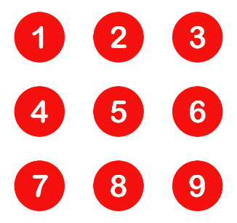The game starts in a paused mode, where the player is given the opportunity to prepare himself for the first enemy wave. 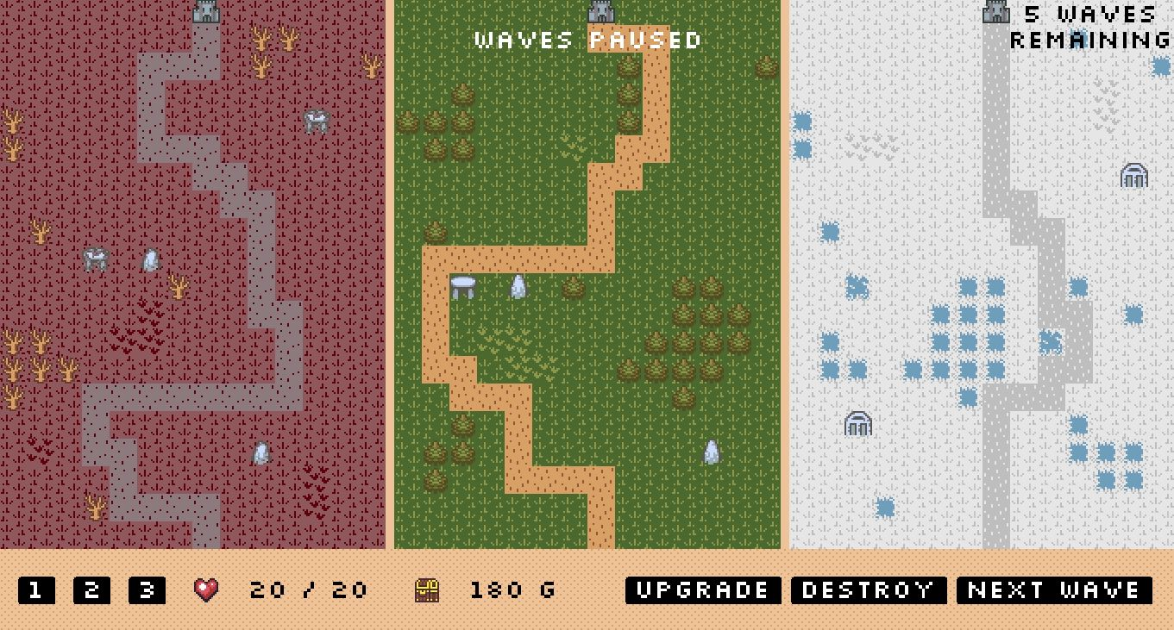

* Click on a tower button (,  or ) to invoke the placement.
* Select a spot as you see fit (please note that enemies only walk on the 3 paths   ). A valid selection will be indicated as a green highlight on the tile. Try to cover as much of the path as possible.
* After your placement, your gold  will have been reduced by the price of the tower.
* You are also able to upgrade or destroy your towers. For instructions on that, please refer to later sections.
* Place as many towers as you like. Once you feel ready, press the  button to call the first enemy wave. Please note that you can do any of the above steps during the ongoing wave as well.

After the first wave, you will notice how your wave counter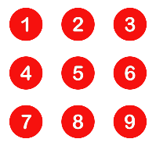has been reduced and in case some enemies made it to your fortress; your health  will have dropped.

Repeat the process and fight through each enemy wave.

# Tower Manipulation

## Upgrade

Towers can be upgraded in order to improve their damage, range and fire frequency. Some enemies are strong while others are fast, upgrading a tower can be a good strategy.

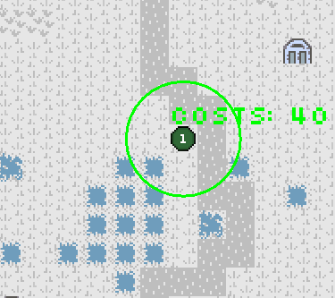

* Press the  button to initialize the tower upgrade.
* Hover your mouse over the tower ( for instance) to see the upgrade’s costs and new range. (damage increase will not be visible) and click on it to make the upgrade.

After your upgrade, you will notice that the tower’s level has been increased by one.

## Destroy

For strategic reasons it can be necessary to destroy a tower. Towers can always be destroyed to get a fraction of the gold  back.

* Press the  button to initialize a tower destruction and click on the tower you want to delete.

After a tower destruction, you will notice that your gold  count has been increased.

## Multi Towers

Next to mono towers , it also possible to build double  and triple  towers by pressing the  or the  button.

* 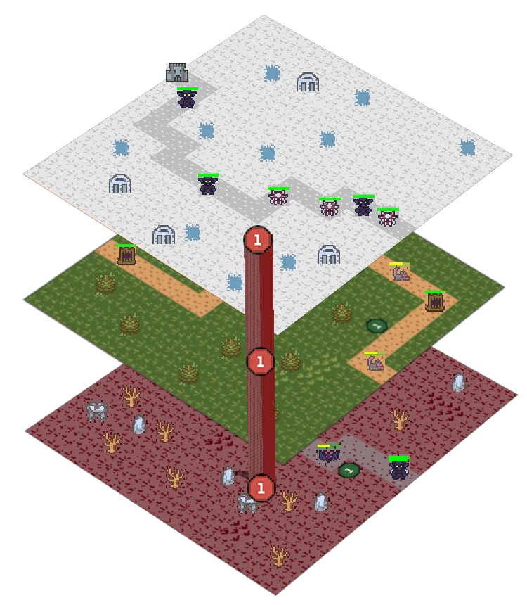Such a tower exists on multiple layers. Imagine double and triple towers as one big tower going through multiple layers:
* Double and triple towers require the same amount of gold  as a mono tower **BUT** the upgrades are much more expensive than those of mono towers.